Question | Solution | Marks | Comments
- $P=\left(A^{1}{UB}^{1}\right)=P=\left(A^{1}\right)+P\left(B^{1}\right)-P(A^{1}nB^{1}$)
$0.8=P\left(A^{1}\right)+\left[P\left(AnB^{1}\right)+P (A^{1}nB^{1})\right]-P(A^{1}nB^{1}$)
$$0.8 p\left(A^{1}\right)+P\left(A^{1}{UB}^{1}\right)$$
$$0.8=P\left(A^{1}\right)+0.3$$
P(A) = 1-(0.8-0.3)
P(A) = 0.5
b) P($A^{1}/B)$ P=

 | - Let x be the number of defective items
(a) Let the cost of fuel be y
x | 30 | 40 | 45
y | 16400 | 17200 | y

The cost of fuel is shs. 17600

b)
x | 20 | x | 30
y | 15600 | 1600 | 16400

Distance is 25km
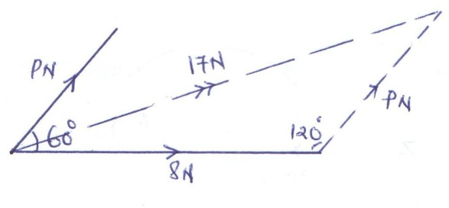

Using cosine rule

x | y
1  1.3  1.6  1.9  2.2  2.5 | 2.7183 | 3.6693  4.9530  6.6859  9.0250
Total | 14.9008 | 24.3329

Percentage error =
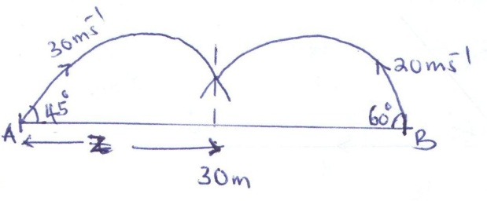

For panicle I
For particle II

x | F(x) f(x)=p(x=x) |  | Xp(x=x)
1  2  3  4  5 | 0.2  0.32  0.67  0.9  1.0 | 0.2  0.12  0.35  0.23  0.1 | 0.2  0.24  1.05  0.92  0.5

(i)

(ii)
Marks | f | x | fx | cf | c/b | c/w | f.d
10-15  15-25  25-30  30-35  35-45  45-50  50-60  60-80 | 2  8  17  26  24  16  6  1 | 12.5  20  27.5  32.5  40  47.5  55  70 | 25  160  467.5  845  960  760  330  70 | 2  10  27  53  77  93  99  100 | 9.5-15.5  14.5-25.5  24.5-30.5  29.5-35.5  34.5-45.5  44.5-50.5  49.5-60.5  59.5-80.5 | 6  11  6  6  11  6  11  21 | 0.3  0.7  2.8  4.3  2.2  2.7  0.6  0.1
 | £f=  100 |  | £fx=  3617.5

B(i) mean mark
= =

(ii) Semi-interguative range

semi-interquartile range = 7.3945 (4dp)
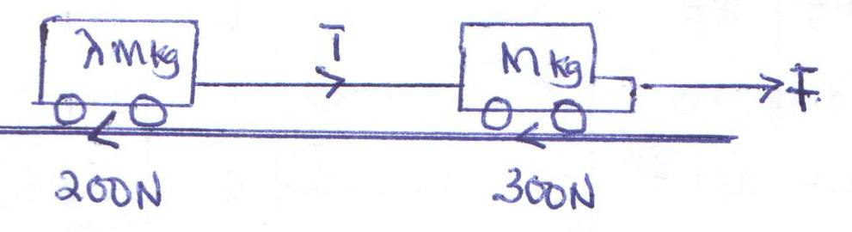

For the car : F –(T+300)=Ma------(i)
For the trarter: T-200 = ma…….(ii)
Solving (i) and (II)
Gives
as required

b) when $T=500, a=0.3{ms}^{-2}$ and m?
from (i)

From (iii)
Let x represent the height of the newly developed variety of maize
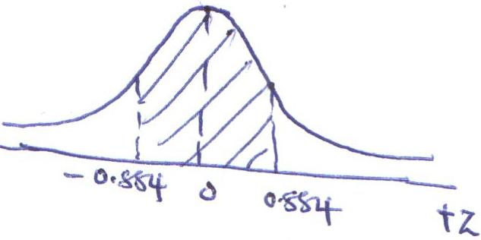

b)
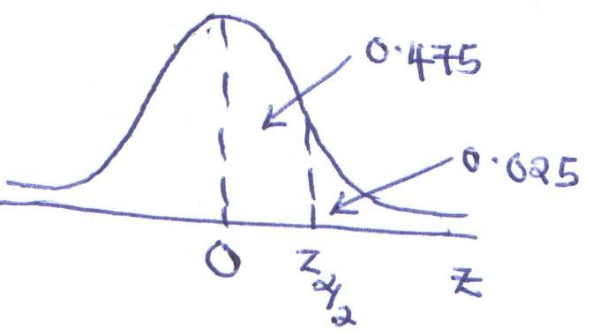

The confidence interval is
as required

ii)

(iii)
x | 0 | 1 | 2
F(x) | 0 | $$\frac{3}{4}$$ | 0

Graph of f(x)
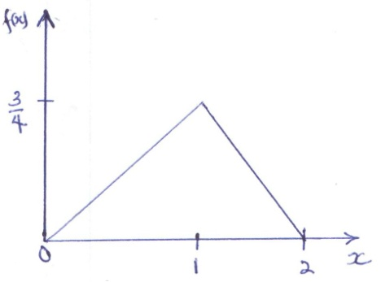

iv)
Let Z=xy²
keeping x constant
Keeping y constant
DZ=Error in x + error in y
Relative error
as required

b)
Value | Error | Max | Min
a 1.50  b -13.3  c 9.200 | 0.005  0.05  0.0005 | 1.505  -13.25  9.2005 | 1.495  -13.35  9.1995

(i)

(ii)

(iii)

b)
Body | weight | Distance of the G.O.G from the base
Remainder  $$-$$  = | =

as required

